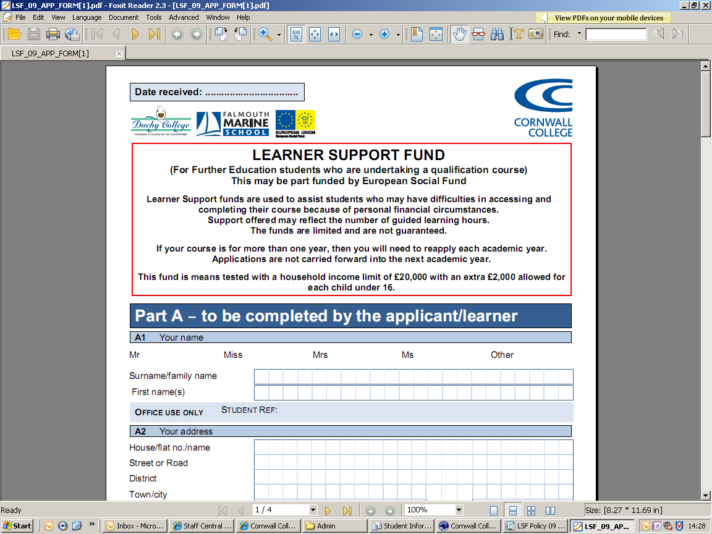

CORNWALL COLLEGE

POLICY AND GUIDANCE FOR THE DISTRIBUTION OF
FURTHER EDUCATION FE BURSARIES AND
FREE COLLEGE MEALS

2015 - 2016

Unless otherwise stated the FE Bursary Funds in this document relate to FE Bursary Funds (16-18) and Discretionary Learner Support Funds – dLSF (19 +)

TCCG refers to The Cornwall College Group
Introduction

The Cornwall College Group (TCCG) believes that every individual deserves the opportunity to access education and training to develop themselves, both personally and professionally. We recognise that for some people this can present more of a challenge, in terms of paying for essential costs such as travel to college and childcare. To support these individuals the Government and TCCG allocate a series of Bursary funds for people of different ages groups to support them with some of these costs. In line with Government guidance, the main priorities for this funding are students who are economically or socially disadvantaged, who need support to assist them in attending and have financial difficulties.

Policy Statement

It is the intention of TCCG to ensure that all learners receive appropriate support from the relevant sources. The College administers internal and external Further Education financial support funds for learners whose access to, or completion of, education may be affected by financial factors. The College uses the FE Bursary Fund to support learners according to their personal financial circumstances.
This document sets out how the College uses its Guaranteed Bursary and FE Bursary Funds allocations to support learners financially. Guidance relating to the other funding is available separately from Student Services.

Most of the Bursary Funds are cash limited and eligible learners may not all be successful.

This policy applies to Government funded learners only.

Support available for learners aged 16 -18

Guaranteed Bursary

The FE Bursary Fund offers an annual Guaranteed Bursary of £1,200* for young people who are aged 16-18 at the start of their course and are:

- Looked after (in care)
- A Care Leaver
- In receipt of Income Support or Universal Credit in their own name
- In receipt of both Employment Support Allowance (ESA) and Disability Living Allowance (DSA) or Personal Independent Payments (PIP)

This fund will be paid in regular weekly instalments direct to the learner’s bank account subject to specific criteria such as regular attendance

Learners who receive a Guaranteed Bursary will also be eligible for general funding from the FE Bursary Funds.

This fund is not means tested.

*Learners who start later in the year and those on short courses will receive pro-rata payments

FE Bursary Fund

Bursary funds cannot be used to support the day-to-day living costs of an individual learner, however, it may choose to do so in exceptional circumstances to meet individual needs.

Applications for support are considered individually to ensure that those who are most in need receive help. Funds are means tested and will only be granted where a genuine need for assistance has been demonstrated. Not all applications are successful.

Support will be subject to satisfactory attendance. If termly attendance falls below TCCG target, financial assistance can be withheld. Tutors will be consulted regarding assessment of progress and attendance to determine whether to continue with the financial assistance. In some cases financial support will be withdrawn following consultation with Personal and Senior Learning Advisors.
Assistance will only be granted during term time and will not normally be considered for support during vacation periods.

----------------------------------------------------------------------------------

Award categories

- Learner Transport
- Severe Hardship – dependant on individual circumstances
- UCAS fees and possible contribution towards interview costs

---------------------------------------------------------------------------------

Learner Transport:-

Learners with a household income of less than £31,000

TCCG offers a range of support through the FE Bursary Fund to learners aged between 16-18 years, with a household income below £31,000.

- household income of less than £16,000 per year learners are eligible for a FREE bus pass
- household income of £16,000 to £21,000 learners are eligible for a bus pass at a subsidised rate of £100 per year
- household income of less than £31,000 students are eligible for a bus pass at a subsidised rate of £200 per year

Learners will be expected to use a college bus, unless circumstances mean that they have to use a car eg the learner has a disability or children who have to be collected from school or childcare. Learners living within a three mile radius are not eligible

-------------------------------------------------------------------------------------

UCAS fees and a contribution to interview travelling expenses
Depending on your circumstances there may be support available for UCAS fees and interview travelling expenses. If you require this support during your time at college please come and talk to the Student Services staff who will advise you further.
-------------------------------------------------------------------------------------------------------

Residential Bursary Fund (RBF)

The Residential Bursary Fund (RBF) is intended to provide financial support towards the costs of accommodation for learners studying our specialist courses which are mostly delivered at Duchy Stoke Climsland, Falmouth Marine School and Newquay College. Some learners may need to be resident during term-time in order to participate because their chosen course is not available locally. Please contact Student Services for further information.
-------------------------------------------------------------------------------------------------------

Severe Hardship

In exceptional circumstances learners may be supported when experiencing severe hardship. This is dependent on individual circumstances.
-------------------------------------------------------------------------------------------------------

Further Support available

Free College Meals

Students between the ages of 16 and 18 on 31st August 2015 will be eligible for free meals, if parents or guardians are in receipt of certain benefits.
Students who are in receipt of benefits in their own right will also qualify.
Students aged between 19 and 25 who have an LDA or EHC Plan and ESF funded students aged between 16 and 18 on 31st August 2015, are also entitled to a free meal, if they meet the income eligibility criteria
Qualifying benefits:
- Income Support
- Income-Based Jobseeker’s Allowance (not Contribution based)
- Child Tax Credit (CTC) and have an income of no more than £16,190
- Guarantee element of State Pension Credit
- Support under part V1 of the Immigration and Asylum Act 1999
- Income related Employment and Support Allowance (ESA)
- Working Tax Credit run-on paid for 4 weeks after you stop qualifying for Working Tax Credit
- During the initial roll out of the benefit, Universal Credit
- Please note, if you are receipt of Working Tax Credit, you do not qualify for Free College Meals, even if your annual income is below £16,190

Childcare support for learners aged 16 to 20

Care to Learn is a government funding scheme to support parents under 20 years of age with childcare costs. This childcare support will not affect your own or your family's benefits or allowances. This support is not means tested and you do not have to be in receipt of benefits or a low income in order to qualify for this support. . Please contact any of our Student Services departments for more details (numbers at the end of this document).

Support available for learners aged 19+

Award categories

- Tuition fees (80%) household income less than £21,000
- Learner Transport household income less than £21,000
- Childcare Support household income less than £21,000
- Residential Access Fund household income less than £21,000
- UCAS fees household income less than £21,000
- Interview travel support household income less than £21,000
- Severe Hardship assessed on individual circumstances

Tuition fees
Depending on age, qualifications undertaken and/or benefits/allowances claimed learners may not have to pay tuition fees. In certain circumstances 80% of the learners tuition fees may be funded by the FE Bursary Fund. The remaining 20% will be paid by the learner on enrolment. Learners will need to check with the admission office to see if they are eligible for fee remission.

-------------------------------------------------------------------------------------------------------

Learner Transport

Support to assist with transport is available to learners aged 19 or over at the start of their course. Learners may be able to use a college bus, or receive a contribution towards petrol costs. We are unable to support learners living within a three mile radius of the campus they are attending.
--------------------------------------------------------------------------------------------------------------

Childcare Support – for learners aged 20+:-

Assistance may be granted towards the cost of childcare for eligible learners with dependent children aged up to 14 years (18 for children with a disability). This bursary is available only when no government support (Free Early Education) is being received. Support will be considered only for Ofsted registered childcare. Informal childcare (e.g. provided by a relative) cannot be supported.

Learners who have an unemployed partner will not normally be supported with Childcare funding.

Funding will be limited to a maximum of £4,000 per academic year. Please check that there are no price increases intended for the forthcoming year.
Payment is for time-tabled tuition hours only, although exception may be given for those learners who require childcare during work placements as authorised by tutors. Childcare assessments may be subject to change once your timetable has been confirmed. If the stated hours on your application form are more than your confirmed timetabled hours your childcare allocation will be reduced accordingly.
If you decide to change providers the College is unable to pay notice given to your childcare provider. This cost will have to be met by the learner. All learners supported with childcare costs are expected to pay for all ancillary charges e.g. nappies, trips out etc.
The FE Bursary Fund is unable to pay for childcare if the learner is absent from College and has not contacted their tutor or Student Services to report the circumstances or illness; in such cases the learner will be expected to pay 100% of the cost of the childcare for the duration of the absence.
In all but exceptional circumstances payments for childcare will be made directly to the childcare provider monthly, in arrears, upon receipt of an invoice. Retainers for the summer holiday period is not covered by the FE Bursary Fund.
Please do not assume childcare will be paid until you receive a letter stating how much support has been allocated to you.

Residential Access Fund
Learners with a household income of less than £21,000
The Residential Access Fund (RAF) is intended to provide financial support towards the costs of accommodation for those aged 19+ and attending one of our specialist colleges. These include Duchy College Stoke Climsland, Duchy College Rosewarne, Falmouth Marine School and Newquay College. These colleges deliver specialist provision and if the learner’s chosen course is not available locally they may need to be resident during term-time in order to participate. Please contact Student Services for further information.

UCAS fees and a contribution to interview travelling expenses
Depending on your circumstances there may be support available for UCAS fees and interview travelling expenses. If you require this support during your time at college please come and talk to the Student Services staff who will advise you further.
-------------------------------------------------------------------------------------------------------
Severe Hardship

In exceptional circumstances learners may be supported when experiencing severe hardship. This is dependent on individual circumstances.
-------------------------------------------------------------------------------------------------------
Support available for learners aged 24+ in receipt of an
Advanced Learning Loan

- Learning Support household income less than £25,000
- Learner Transport household income less than £25,000
- Childcare Support household income less than £25,000
- Residential Access Fund household income less than £25,000
- UCAS fees household income less than £25,000
- Interview travel support household income less than £25,000
- Severe Hardship assessed on individual circumstances
-------------------------------------------------------------------------------------------------------

Information for all categories as for students aged 19+ and detailed on previous pages

-------------------------------------------------------------------------------------------------------

Eligibility

General eligibility criteria

- Learners must be enrolled on an eligible course. Awards will not be made to learners who are not enrolled, or where an enrolment is pending
- Learners must be able to demonstrate financial hardship (household income below limits specified). Evidence of income is required
- Learners who are eligible for the Guaranteed Learner Bursary do not need to demonstrate financial hardship but must provide evidence of eligibility
- The College reserves the right to make awards to learners who appear to be outside the financial criteria, based on individual and exceptional circumstances
- Learners must meet the residency and other eligibility criteria as set out in the Government Funding Guidance for the relevant academic year
- Learners studying a Higher Education course are not eligible and should contact Student Servicesfor hardship funding
- Learners on any waged Apprenticeship or any learning or training undertaken where a wage is being drawn are not eligible
- Learners must meet the stated age requirements on 31 August 2015

-------------------------------------------------------------------------------------------------------

Childcare Support

Care to Learn – learners aged 16-20

- Young parents must meet the general eligibility criteria
- The young parent must be aged 20 or under on 31 August 2014
- The young parents child(ren) must be placed in Ofsted-registered childcare
- The young parent’s income is NOT assessed
- For full details please contact Student Services

Childcare Support– learners aged 20+

- Learners must meet the general eligibility criteria
- The learner’s child(ren) must be placed in Ofsted-registered childcare
- Learners must be aged 20 or over on 31 August 2014

Assessment of Applications
Applications will only be considered when submitted on the appropriate application form and with the required evidence. Learners aged 20 or over at the start of their course should, in addition, use the Childcare Application Form to apply for Childcare funding

All applications for funding will be considered by set criteria as laid out in this document. Every effort will be made to look at each application on its own merit.

The College aims to ensure that the funds available to support learners are:

- distributed wisely and fairly
- allocated according to individual need, taking into account each individuals' own circumstances
- used to widen access to, and participation in, Further and Higher Education and employment
- used to support priority groups as defined by the government and as appropriate to the local area

Income assessment - general FE Bursaries

- Where a learner is in care (Foster or Local Authority) they will be awarded the highest level of support.
- Learners will be assessed on the annual gross taxable household income of the learner, the learner’s partner or the learner’s parents as appropriate. Awards will not normally be made where a learner’s household income is above threshold.
- Where a learner lives with a partner, the income of both the learner and the learner’s partner will be used for the calculation
- Where a learner is aged 19 or over and lives with their parent(s), each case will be assessed individually to decide whether the learner is dependent on their parents
- Where, because of unforeseen circumstances, a learner’s household income drops in excess of 25% during the academic year, the learner may apply to be reassessed based on the new household income

Required evidence

All applications require evidence of income to be provided. Evidence may include

- P60 issued by current employer dated April 2015
- Photocopies of benefit award letter no more than 3 months old. In exceptional circumstances, where it is not possible to obtain evidence less than 3 months old, we are able to use bank statements showing benefit payments
- Details of accounts for self-employment.
- Tax credit award letter for 2015/2016 showing finalised income for 2014/2015.
- Written confirmation of the young person’s current or previous looked after status
-------------------------------------------------------------------------------------------------------

Applications will be processed from 1st June.

Incomplete applications and or failure to provide supporting evidence will result in the application being returned without being processed
-------------------------------------------------------------------------------------------------------

Notification of award
Fully completed forms, with all supporting evidence attached, will normally be processed within 28 days of receipt but in peak times (summer holidays and the start of the academic year) may take longer. Once your application has been assessed you will receive an award notification letter which will indicate how your award will be paid. If your application is not successful you will be notified. Wherever possible, payments are made via internal transfers within the college.

Payments
Transport payments will be made direct to the college transport department. Personal payments such as mileage claims will be paid directly into learners bank accounts. Childcare payments will be made direct to the childcare provider.
-------------------------------------------------------------------------------------------------------
Attendance Requirements
If attendance falls below the college target on-going funding will be withheld. Tutors will decide whether to reinstate funding based on progress, attitude, and reason for absence.

We will take into account all personal circumstances when determining satisfactory attendance.
-------------------------------------------------------------------------------------------------------

Appeals Procedure
Decisions regarding the payment or non payment of monies from the FE Bursary Fund will be made in accordance with Government guidelines for administration of the fund and TCCG policy.
If you are dissatisfied with any decision regarding the decision to not award funding support you may request an appeal. Your reasons for wanting an appeal should be clearly stated and addressed to Corporate Head of Learner Journey.
Appeals will not be accepted where a turndown has been made due to the funds being exhausted.
Learners who withdraw
Learners who receive an award and later withdraw from their course may be asked to repay this award.

False or Fraudulent Applications
Where learners are found to have intentionally given misleading or inaccurate information the College will claim back the award made. Providing false statements may result in the learner being sanctioned in accordance with the TCCG Disciplinary Policy.
-------------------------------------------------------------------------------------------------------

Support not granted

- If you have not been a resident in the EU for 3 years prior to the start of the course.
- If you have a gross taxable household income that exceeds the limits stated
- Whilst a main programme of study is supported any further or additional add-on courses will not normally be considered for funding . Should there be funds available at the end of the academic year we will then be able to consider these requests. Guaranteed Bursaries are not affected.
- If you are already being supported by another college your application will not be considered.
---------------------------------------------------------------------------------

Data Protection & Confidentiality
The information you provide on this form along with the supporting evidence will be used in confidence for the purpose of processing your application and administering the FE Bursary Fund. This may entail some information being shared with organizations providing services to you which have been paid for by the FE Bursary Fund. As part of the administration of the FE Bursary Fund, information may be shared with the Skill Funding Agency, the Education Funding Agency and other statutory bodies responsible for providing educational funding and support. For further details please contact the TCCG Student Services Manager.

14. Additional assistance
There may be other sources of help which can be accessed for possible financial assistance.

Learner Finances https://www.gov.uk/further-education-

Lifelong Learning http://www.lifelonglearning.co.uk

Learner Money http://www.scholarship-search.org.uk

http://www.family-action.or.uk

Lone Parent Advisor Contact your Local Job Centre

Contact Details

Cornwall College Camborne  Trevenson Road  Pool  Redruth  Cornwall  TR15 3RD | Cornwall College  Newquay  Wildflower Lane  Trenance Gardens  Newquay  Cornwall  TR7 2LZ
 01209 616272/616224 |  01637 857960
Cornwall College  St Austell  Tregonissey Road  St Austell  Cornwall  PL25 4DJ | Cornwall College Saltash  Church Road  Saltash  Cornwall  PL12 4AE
 01726 226618/226405/226622 |  01752 850253226662
Duchy College Rosewarne  Camborne  Cornwall  TR14 0AB   01209 722135 | Duchy College Stoke Climsland  Stoke Climsland  Callington  Cornwall  PL17 8PB
 |  01579 372227
Falmouth Marine School
Killigrew Street
Falmouth
Cornwall
TR11 3QS
 01326 310310
This policy, together with additional application forms, is available to download from our website:
http://www.cornwall.ac.uk/Learnerfinance

If you need any help in completing the bursary application forms please contact Student Services where staff will be happy to assist you.

If you require this document in larger print please contact Student Services

